

CME Event at Mount Sinai Health Partners

Practice Management for Success in Population Health: Pharmacist and Medical Assistant Staffing

October 29, 2019 • 6:30 pm – 8:00 pm

Mount Sinai Health System
150 East 42nd Street
New York, NY 10017
Rooms 4-A.8-12-16

Course Director
Robert W. Fields, MD, MHA
Senior Vice President and Chief Medical Officer, Population Health
Mount Sinai Health System
Assistant Professor, Department of Family Medicine and Community Health
New York, NY

Faculty
Ruchi Tiwari, PharmD, MS
Director of Pharmacy, Population Health
Mount Sinai Health Partners
New York, NY

Provided by
Icahn School of Medicine at Mount Sinai and Mount Sinai Health Partners

Program Description
This CME activity will educate primary care physicians and their practice managers on two topics related to optimal patient care and outcomes in the primary care setting: the business case for including a pharmacist on the care team, and how to ensure adequate medical assistant-to-physician ratios to improve patient care and outcomes. Robert W. Fields, MD, MHA and Ruchi Tiwari, PharmD, MS will share their expertise on pharmacist and medical assistant staffing and the value of these roles in primary care practices. There will also be time for audience Q&A.

Educational Objectives
At the conclusion of this activity, participants will be able to:

- Describe how clinical pharmacists add value to daily workflows and to performance on quality gap closure.

- Describe how increased medical assistant-to-provider ratios are not only financially sustainable but can improve patient and provider experience.

- Identify operational processes that would benefit from the additional support of clinical pharmacy and/or additional medical assistants.

- Identify revenue opportunities provided by the delivery models described during the session.

- Build practice protocols that assist the pharmacists and medical assistants to close quality gaps and improve screening rates for primary care patients.

Target Audience
Primary care physicians and their practice managers

Accreditation
The Icahn School of Medicine at Mount Sinai is accredited by the Accreditation Council for Continuing Medical Education to provide continuing medical education for physicians.

Credit Designation
The Icahn School of Medicine at Mount Sinai designates this live activity for a maximum of 1.5 AMA PRA Category 1 Credit(s)™. Physicians should claim only the credit commensurate with the extent of their participation in the activity.

Verification of Attendance
Verification of attendance will be provided to all professionals.

Special Needs
The Icahn School of Medicine at Mount Sinai is in full compliance with provisions of the Americans with Disabilities Act (ADA) and is accessible for individuals with special needs. If you would like to attend this conference and require any special needs or accommodations please contact the Page and William Black Post-Graduate School of Medicine at 212-731-7950.

Faculty Disclosure
It is the policy of the Icahn School of Medicine at Mount Sinai to ensure objectivity, balance, independence, transparency, and scientific rigor in all CME-provided educational activities. All faculty participating in the planning or implementation of a provided activity are expected to disclose to the audience any relevant financial relationships and to assist in resolving any conflict of interest that may arise from the relationship. Presenters must also make a meaningful disclosure to the audience of their discussions of unlabeled or unapproved drugs or devices. This information will be available as part of the course materials.

Registration Information
Registration is complimentary

Meeting Location
Mount Sinai Health System
150 East 42nd Street
New York, NY 10017
Rooms 4-A.8-12-16

Conference Information
http://mssm.cloud-cme.com
Office of CME at 212-731-7950 or e-mail: cme@mssm.edu

Agenda

5:30 – 6:30 pm Registration and Buffet Dinner

6:30 – 6:40 pm Welcome and Opening
Robert W. Fields, MD, MHA

6:40 – 7:00 pm How Clinical Pharmacists Can Add Value to Primary Care Practice
Ruchi Tiwari, PharmD, MS

7:00 – 7:20 pm Review of and Workflow for Enhanced Medical Assistant Role in Primary Care Practice
Robert W. Fields, MD, MHA

7:20 – 7:30 pm Audience Q&A

7:30 – 7:50 pm Discussion Groups and Brainstorming: Use Cases in Your Practice

7:50 – 8:00 pm Report Out, Discussion, Wrap Up

FACULTY DISCLOSURE

It is the policy of the Icahn School of Medicine at Mount Sinai to ensure objectivity, balance, independence, transparency, and scientific rigor in all CME-provided educational activities. All faculty participating in the planning or implementation of a provided activity are expected to disclose to the audience any relevant financial relationships and to assist in resolving any conflict of interest that may arise from the relationship. Presenters must also make a meaningful disclosure to the audience of their discussions of unlabeled or unapproved drugs or devices.

Please find below the compiled information we have received on disclosure of relevant financial relationships from activity faculty and planners. The following faculty/planners have reported that they have no relevant financial relationships to disclose:

PLANNING COMMITTEE/FACULTY

Robert W. Fields, MD, MHA
SVP, Chief Medical Officer, Population Health
Assistant Professor, Department of Family Medicine and Community Health
Mount Sinai Health Partners, Mount Sinai Health System
robert.fields@mountsinai.org

Arshad K. Rahim, MD, MBA, FACP
Senior Medical Director of Population Health
Assistant Professor of Medicine
Mount Sinai Health Partners, Mount Sinai Health System
arshad.rahim@mountsinai.org

Ruchi Tiwari, PharmD, MS
Director of Pharmacy, Population Health
Mount Sinai Health Partners
ruchi.tiwari@mountsinai.org

Lisa Bloch, MS
Senior Director, Provider Communications
Mount Sinai Health Partners
lisa.bloch@mountsinai.org

COURSE FACULTY

Robert W. Fields, MD, MHA
SVP, Chief Medical Officer, Population Health
Assistant Professor, Department of Family Medicine and Community Health
Mount Sinai Health Partners, Mount Sinai Health System
robert.fields@mountsinai.org

Ruchi Tiwari, PharmD, MS
Director of Pharmacy, Population Health
Mount Sinai Health Partners
ruchi.tiwari@mountsinai.org

EVALUATION/CME CERTIFICATE

Your comments are essential for improving the effectiveness of Icahn School of Medicine at Mount Sinai’s continuing medical education activities. The instructions to complete the conference evaluation and download your CME Certificate are below.

If you have any issues attaining your CME Certificate, please email cme@mssm.edu

Step 1: Visit our CME website at https://mssm.cloud-cme.com

Step 2: Click "Sign In" on the top left, and sign in using your email address and CloudCME profile password

Step 3: If you do not know your CloudCME profile password, click “Forgot Your Password?” link and you will receive an email with instructions to reset/create your password.

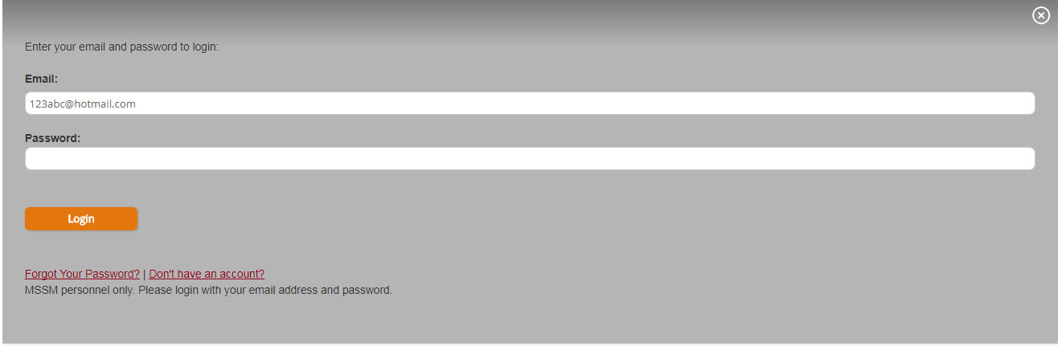

Step 4: Sign-in and click the "My CME" button on the top right

Step 5: Click "Evaluations and Certificates" - this will allow you to view evaluations that need to be completed.

